**INTEGRATION TESTING**

**Module:**Carpark.java

**Tester:** Harsimranjeet Kaur

Import Classes:

* IAdhocTicket
* IAdhocTicketDAO
* ISeasonTicket
* ISeasonTicketDAO

Implemented Class:

ICarpark

Number of methods: 17 and one constructor

**Use Case:**

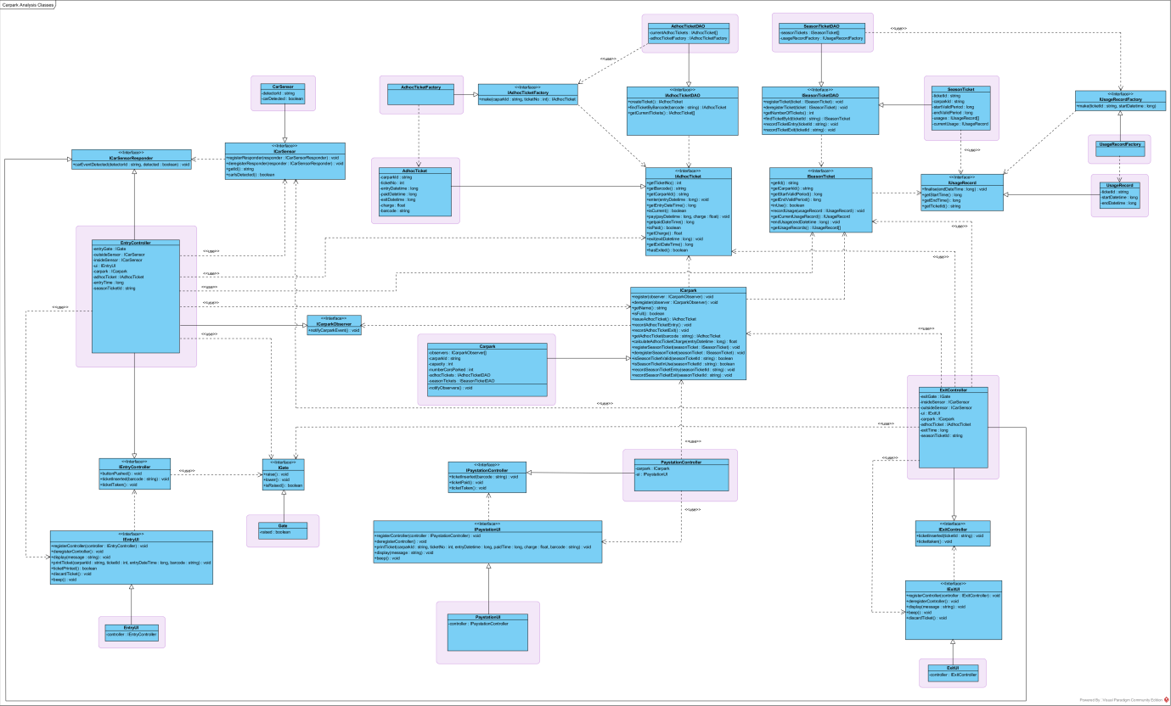

This diagram display overall structure of all classes which define the functionality of the java application. Carpark.java is connected with classes such as Interfaces classes mainly ICarpark interface.

(Running in NetBeans)

**Calculate Charge on basis of entry time**

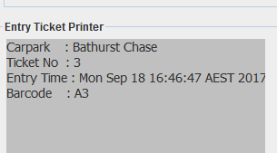

**Adhoc Ticket**

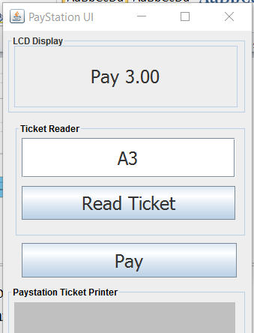

**Calculate charge**

By providing barcode of ticket it calculates the charge for ticket.

Tested Status:

|  |  |  |  |
| --- | --- | --- | --- |
|  | | **Testing Status** | **Bug** |
| **Modules** | Carpark.java | Done | 36 |
| **Implement Class** | ICarpark | Done |  |
| **Import Classes** | IAdhocTicket  IAdhocTicketDAO  ISeasonTicket  ISeasonTicketDAO | Done  Done  Done  Done |  |
|  |  |  |  |

**Error Screenshot in command mode**

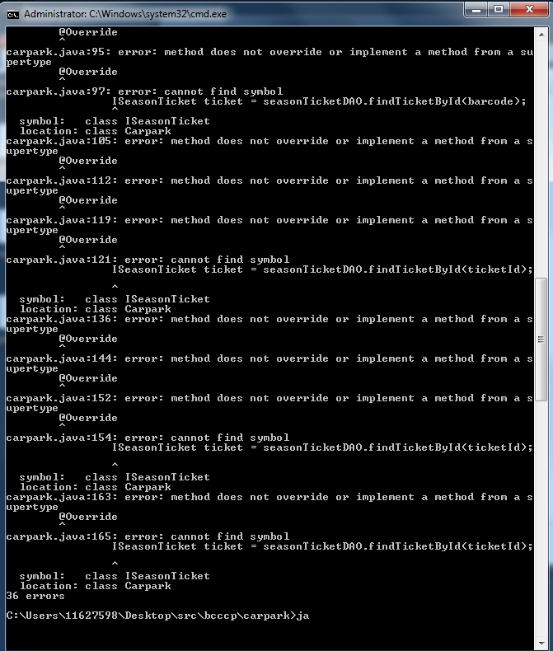

**Carpark.java**